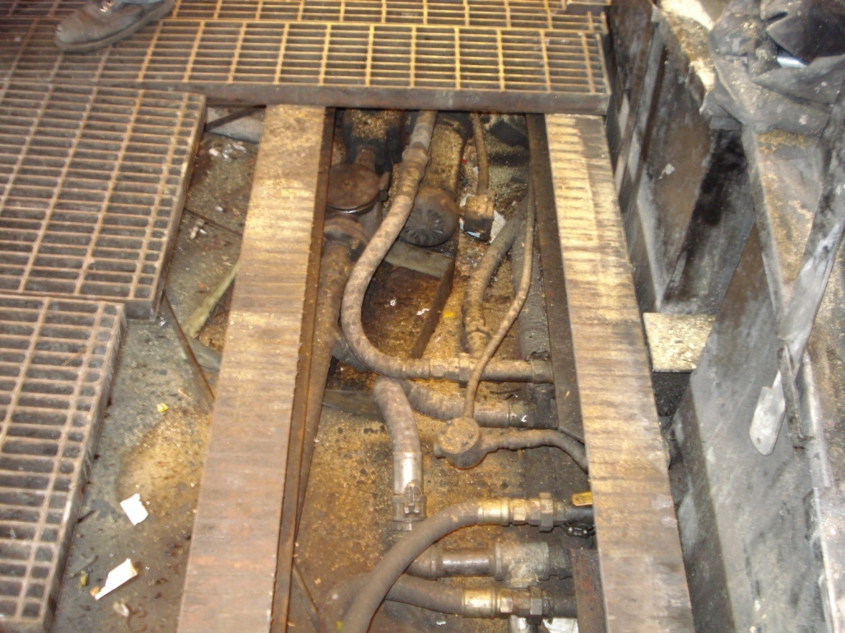

Recirculating pipe?

Connected?

HW drum washer sump pipe to HW tank

CUP drum washer sump pipe to HW tank

HW drum washer spray nozzle pipe from sump

HW drum washer sump pipe to spray nozzle

CUP tank pipe to spray nozzle

HW drum washer

HW tank pipe

CUP drum washer

Figure 1: Piping system

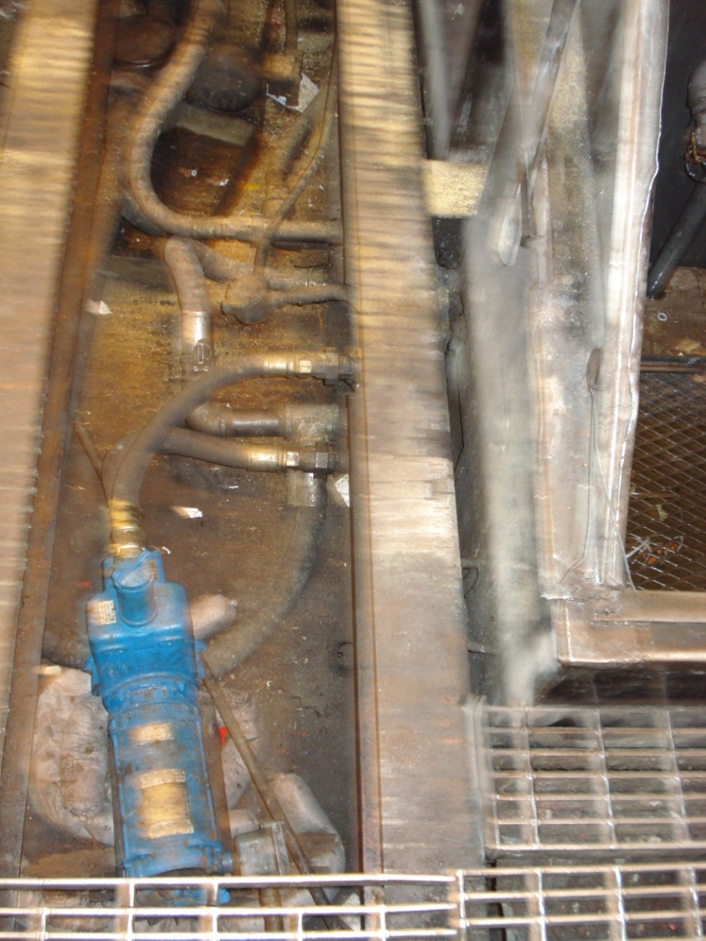

Recirculating pipe?

Pipe from drum washers to HW tank

HW drum washer sump pipe to HW tank

CUP drum washer sump pipe to HW tank

HW drum washer spray nozzle pipe from sump

HW drum washer sump pipe to spray nozzle

CUP tank pipe to spray nozzle

HW tank pipe

Figure 2: Piping System