Crowley Logistics
12/30/2020
4300 McIntosh Rd.
Ft Lauderdale, FL 33316
Dear Mr. Hayes:
I am writing to report our completion of the Crowley Logistics P2 Project authorized and executed under the oversight of your office. The following is the present status of the two phases outlined in our P2 Project proposal finalized and agreed upon on 6/10/2020.
Phase I of the project was to mitigate the potential environmental damage from the waste disposal of nitrile gloves used for taking temperatures of employees during the global health crisis. This PPE use went from 20 pairs a day to roughly 200. The mitigation strategy for this waste stream was to start a recycling program for these gloves. This was a waste stream that was not permitted to be recycled through our recycling contractor, and required separate collection points and arrangements for special recycling considerations.
TARGET: 6 boxes were to be placed at points of use for collection of gloves, and then a recycler would come and remove them for recycling.
UPDATE as of 10/2020: To date 5 boxes to collect and dispose of gloves have been placed in location where gloves are predominantly used to capture the waste stream. 6 were purchased, but only 5 are needed at present. Disposal cost of the gloves was combined into the purchase cost. Gloves will be sent back to recycler as soon boxes are full. The receipt for the purchase of collection boxes and the recycling service cost are attached.
Update as of 12/21/2020
5 boxes to collect PPE are still actively being filled on the Terminal. A total of 26 lbs has been collected to date for disposal to Terracycle. The sixth box is being held in reserve.
Stage 2 of the Project was to reduce fuel consumption and decrease carbon emissions from vehicle use. Calculation for this by hours as written in the proposal is not aligning with our resulting CO2 emissions. We have switched calculation methods to isolate the five yard trucks that are being evaluated and compared the fuel consumption year over year for the time period.
The trucks in reduced use were yard truck number:
CMPW 880971; CMPW 880985; CMPW 880986; CMPW 880921; CMPW 880948
 |  |  | Gallons of Diesel |  | CO2 Emissions in Metric Tons |  | Gasoline Conversion for EPA Equivalency Calculator
 | Total Gallons Used for 2019 |  | 31107 |  | 280 |  | 27529
 | Total Gallons Used for 2020 |  | 11611 |  | 118 |  | 11650
 | CO2 Emissions Saved |  |  |  |  | 162 metric tons
Additional Carbon Emissions Reduction based on employees now working permanently from home. 26 employees who were commuting 30 miles average (1560 miles) commute a day @22 mpg from July 1-Dec 31 (132 days).
Total gallons saved: 205,920/22=9360 gallons saved=83.2 Metric Tons of CO2 saved.
Total savings in Metric Tons of Carbon Emissions=83.2+162=245.2
Please feel free to call me with any questions you have. Additional photos and receipts to follow. Waste receipt for boxes is on a separate attachment.
Sincerely,
Emily Reiblein
Emily Reiblein-Director of HSSE Crowley Logistics

Waste for gloves- boxes were made larger to capture other PPE that was not previously recycled, but that the new glove waste recycler can now take.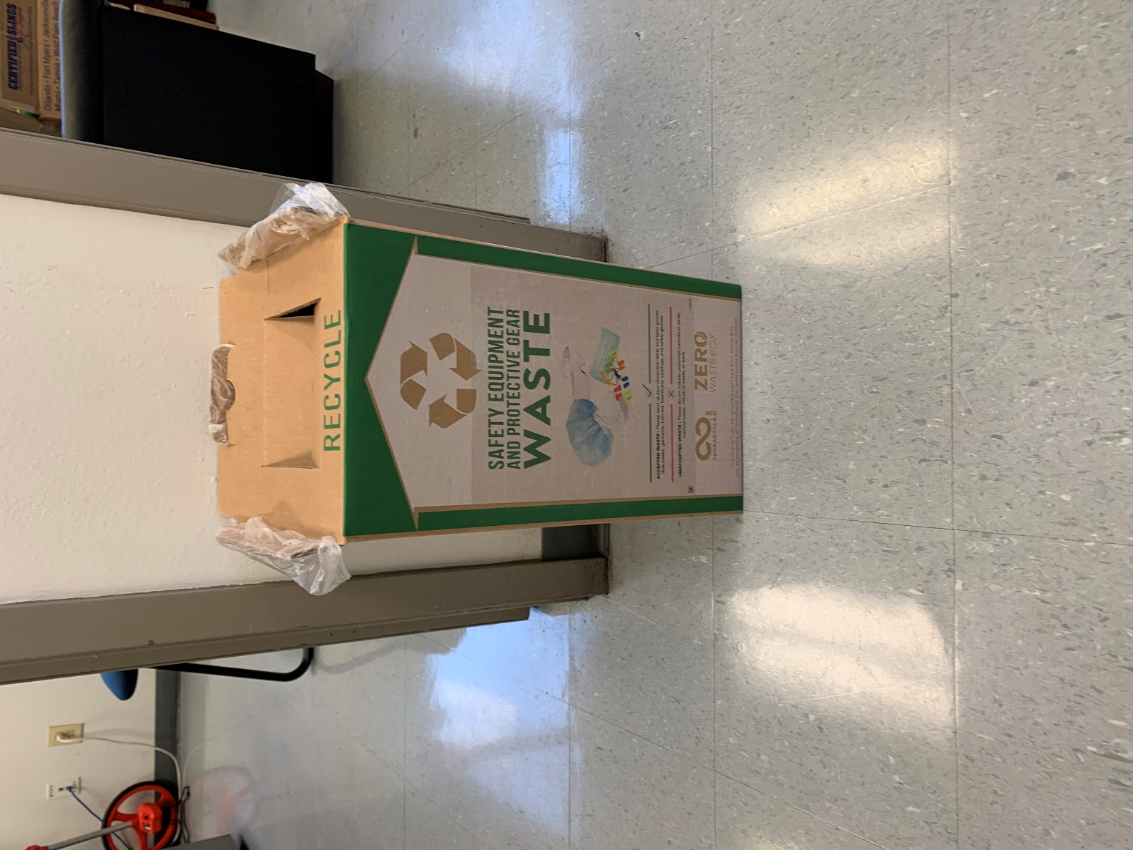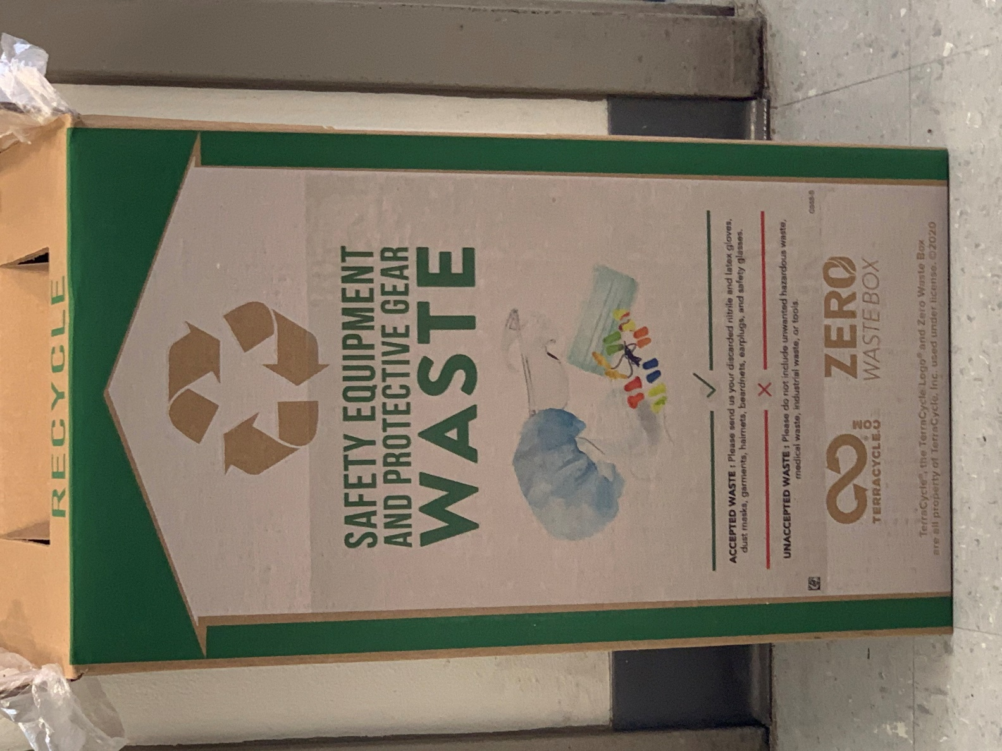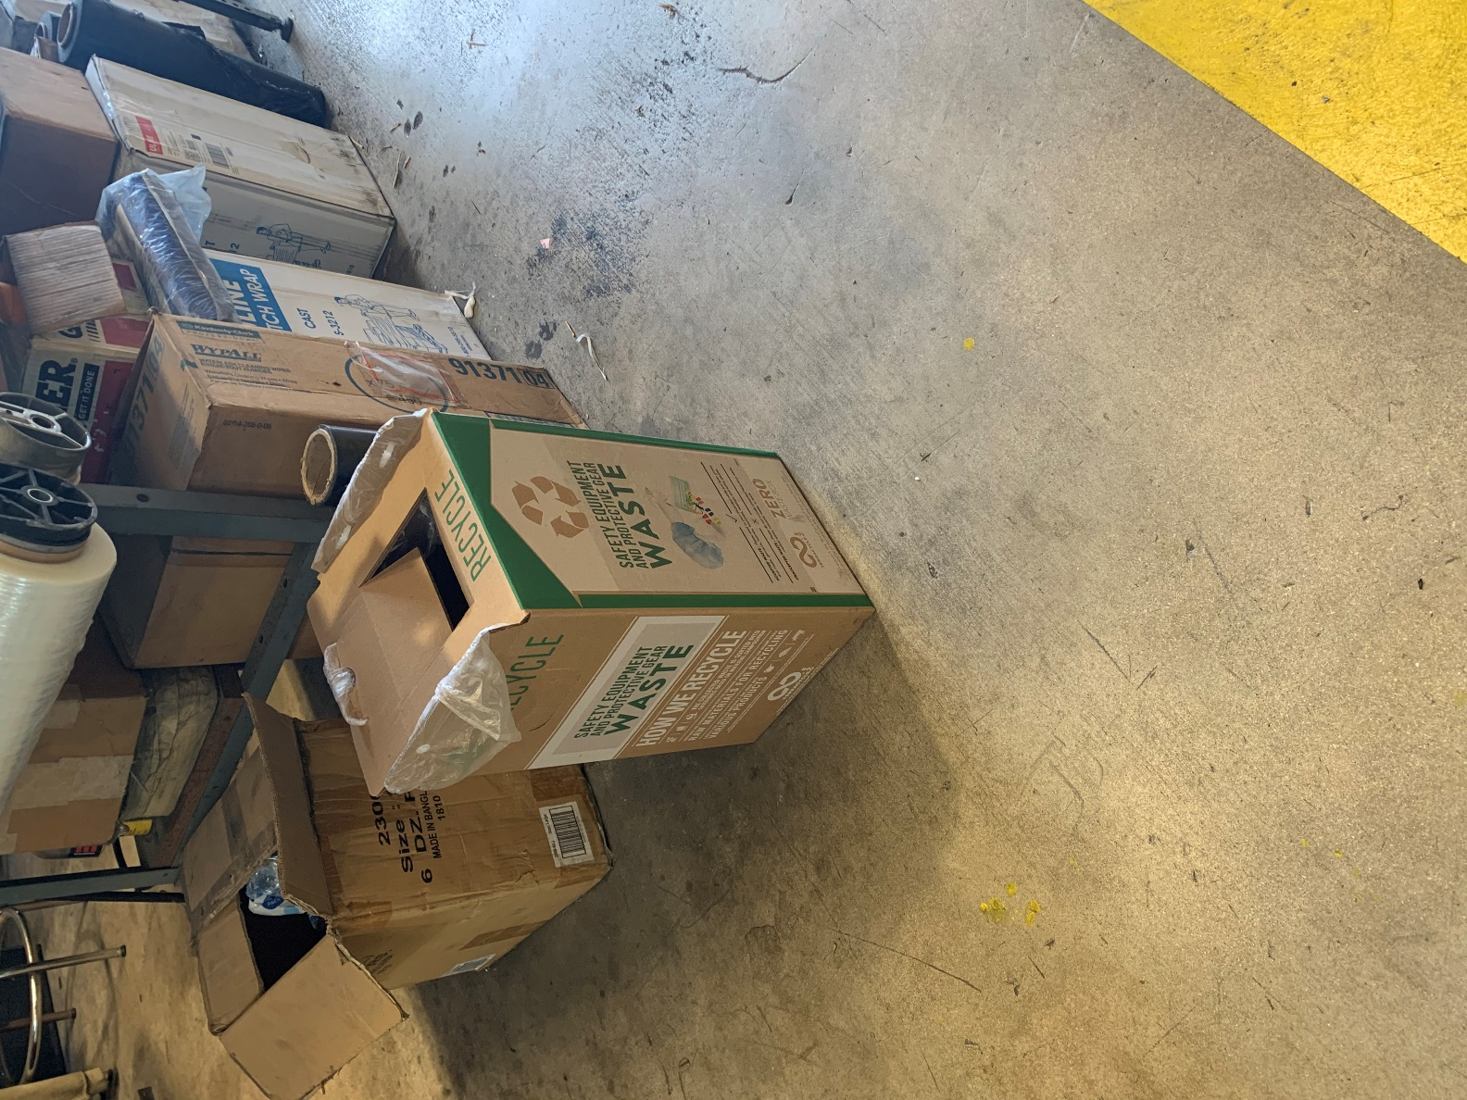

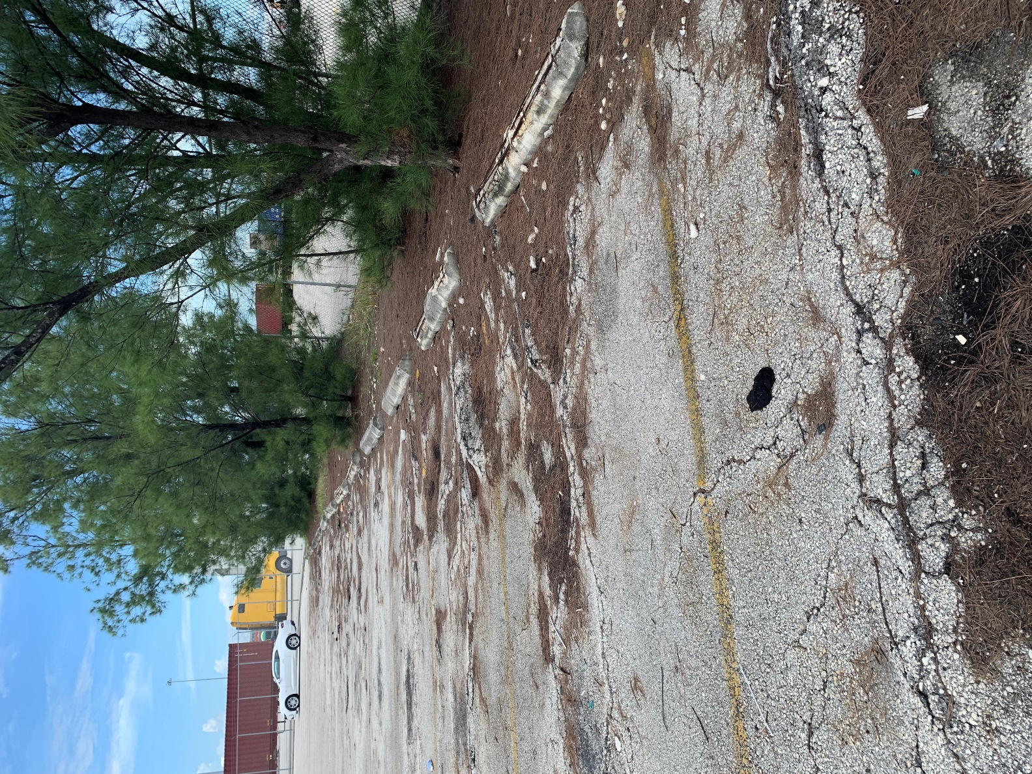
Empty Parking Lot with employees not at work.

