Interoffice Memorandum
_____________________________________________________________________

TO: File: Volusia County Tomoka Farm Road Landfill Class I

From: Laxsamee Levin

Date: April 20, 2012

Subject: Intent to Issue – Permit Application No. SF64-0078767-028
____________________________________________________________________

A search of the Legal Case Tracking System for this application number on April 20, 2012, resulted in the message “Query retrieved 0 records,” indicating that no petition was filed in response to the published notice on April 2, 2012.

/ll

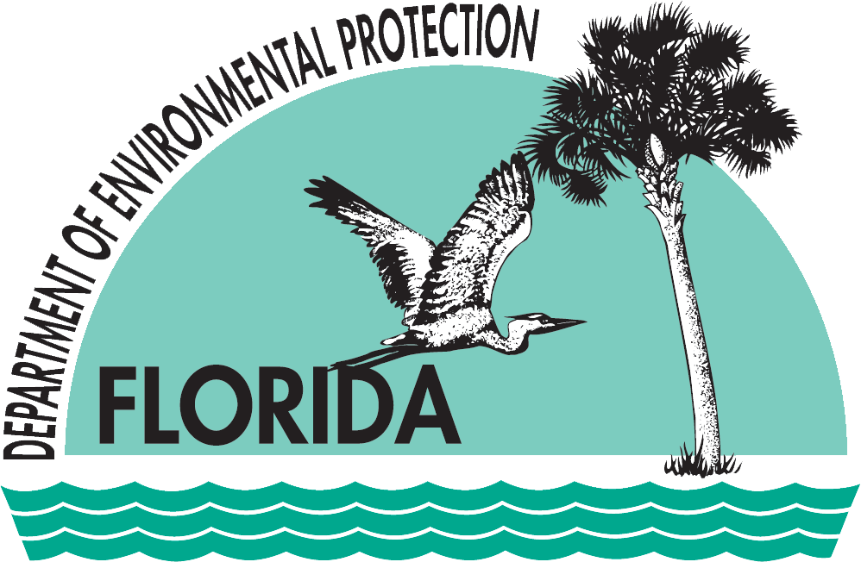 | Florida Department of  Environmental Protection  Central District  3319 Maguire Boulevard, Suite 232  Orlando, Florida 32803-3767 | Rick Scott  Governor  Jennifer Carroll  Lt. Governor  Herschel T. Vinyard, Jr.  Secretary

