July 15, 2013

Mr. Michael K. Dunaway
Florida Department of Environmental Protection
Solid Waste Section
2600 Blair Stone Road/MS 4565
Tallahassee, FL 32399

Subject: Trail Ridge Landfill Solid Waste Permit Hydrogeological Information

Dear Mr. Dunaway:
Please find enclosed two electronic copies of the DRAFT Trail Ridge Landfill Groundwater Modeling Memorandum and Water Quality Monitoring Report. These documents are provided for information purposes to provide background information on the Trail Ridge Landfill Phase 6-14 Class I Cell Expansion Project.
Please contact me at SterlingLM@cdmsmith.com or 904-527-6726 if you have any questions regarding the enclosed report.
Sincerely,
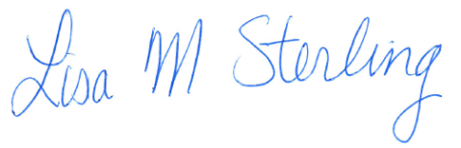

Lisa M. Sterling, P.E.
Project Manager
CDM Smith Inc.

Enclosures+
cc: Henry Freedenberg, FDEP
FILE

