5/19/2014 to Oculus

Review 11/6/2013
- GW quality looks very good. It is reasonable that the few exceedances are natural or from off-site.
- They state:
“Based on SCS’ evaluation of the VLF hydrogeologic data, the groundwater at VLF primarily occurs in the Hawthorn Group and the underlying Floridan aquifer.”

This is geologic apples and oranges—rock type confused with an aquifer. It is all Floridan aquifer.

- At first:
  - the GW maps did not seem reasonable (It is all Floridan aquifer and the Floridan flow should be  like the blue arrow on the Aerial.) These maps have flow to the south.)
  - MW-1B and MW-7A in the NW seem like they must be perched.
But the aerial indicates that both oddities may be explained by a localized GW mound created by the NE stormwater pond. (Similar to the ground water mound at Mid-Florida.

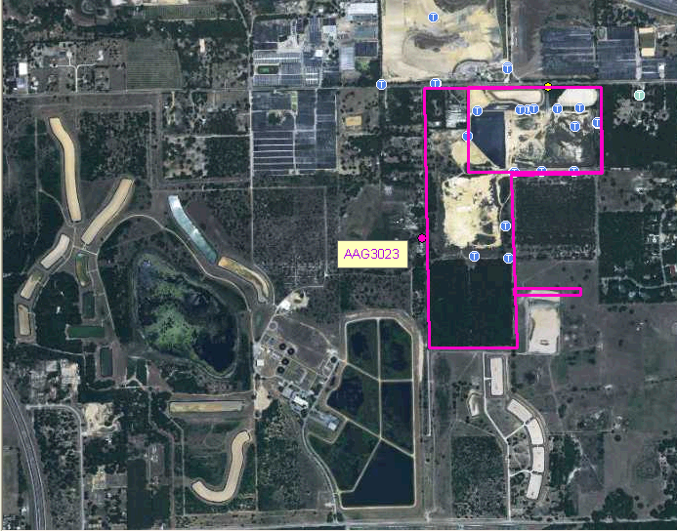
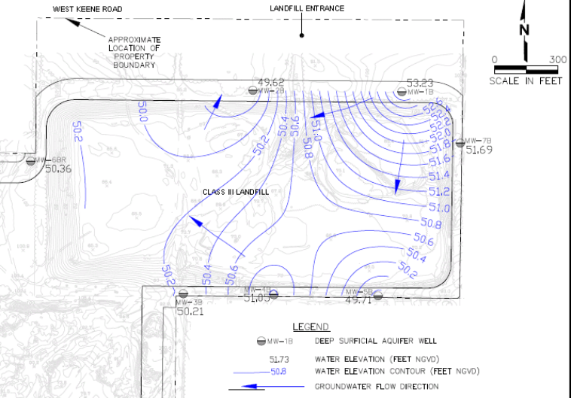

- The report states a couple of times that MW-FL2 appears to be installed in a deep portion of the surficial aquifer zone possibly in a relic karst feature. Beyond saying “based on well logs and similar water levels to surficial aquifer intermediate zone wells” they do not explain their conclusion. All of the information that I have indicates that it is as much of the Floridan as the other two FL wells. Furthermore, ALL of their wells should be classified as Floridan. (Even they note that there is no perched surficial.)

Additional comments 5/19/2014
The hydro geology in this area is among the the most complex in the district because:
  - Ridge sinkhole area
  - Surficial mined out for sand.
  - The clay may have been breached naturally and/or in the mining.
  - Massive RIB system upgradient
  - Stormwater ponds

Because the site is so clean, at this point the difference of opinion appears to be academic. The Department does not plan to debate the issue, unless the issue becomes environmentally significant.

