Memorandum

To: Facility File

CC: Pam Fellabaum, Environmental Consultant
Hazardous Waste
Compliance Assurance Program

From: Homer Butler, Environmental Specialist
Northeast District - Compliance Assurance Program, Hazardous Waste

Date: February 13, 2017

Subject: Water Recovery, LLC. Return to Compliance

Facility or Responsible Party Name: Water Recovery, LLC

Location of Facility or Site: 1819 Albert St., Jacksonville, Florida 32202

Facility or Site ID: FLR 000 069 062

A Compliance Assistance Offer follow-up site visit to the facility was conducted on February 13, 2017. During the visit ir was noticed that:

1. Used oil containers were closed and labeled with the words “Used Oil” (Photo 1).

2. UST 1-P, 2-P and 3-P were closed and in good condition (Photos 2 and 3).

3. A valid EPA ID # and off-load tank# were recorded on the WRI Retail Oil Sale Tracking forms (Attachment 1).

4. Hazardous waste manifests were recorded correctly with analytical acceptance requirements according to WRI’s application permit condition Appendix C-4 (Attachment 2).

5. The facility was conducting weekly PCW tank inspection on a combined WRI inspection form.

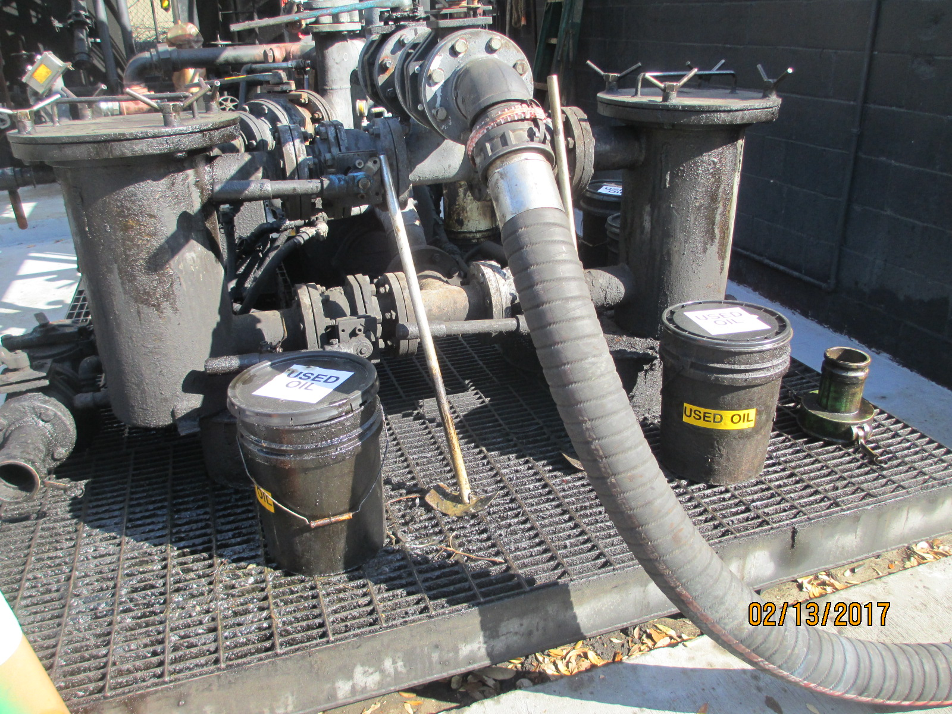

Photo 1

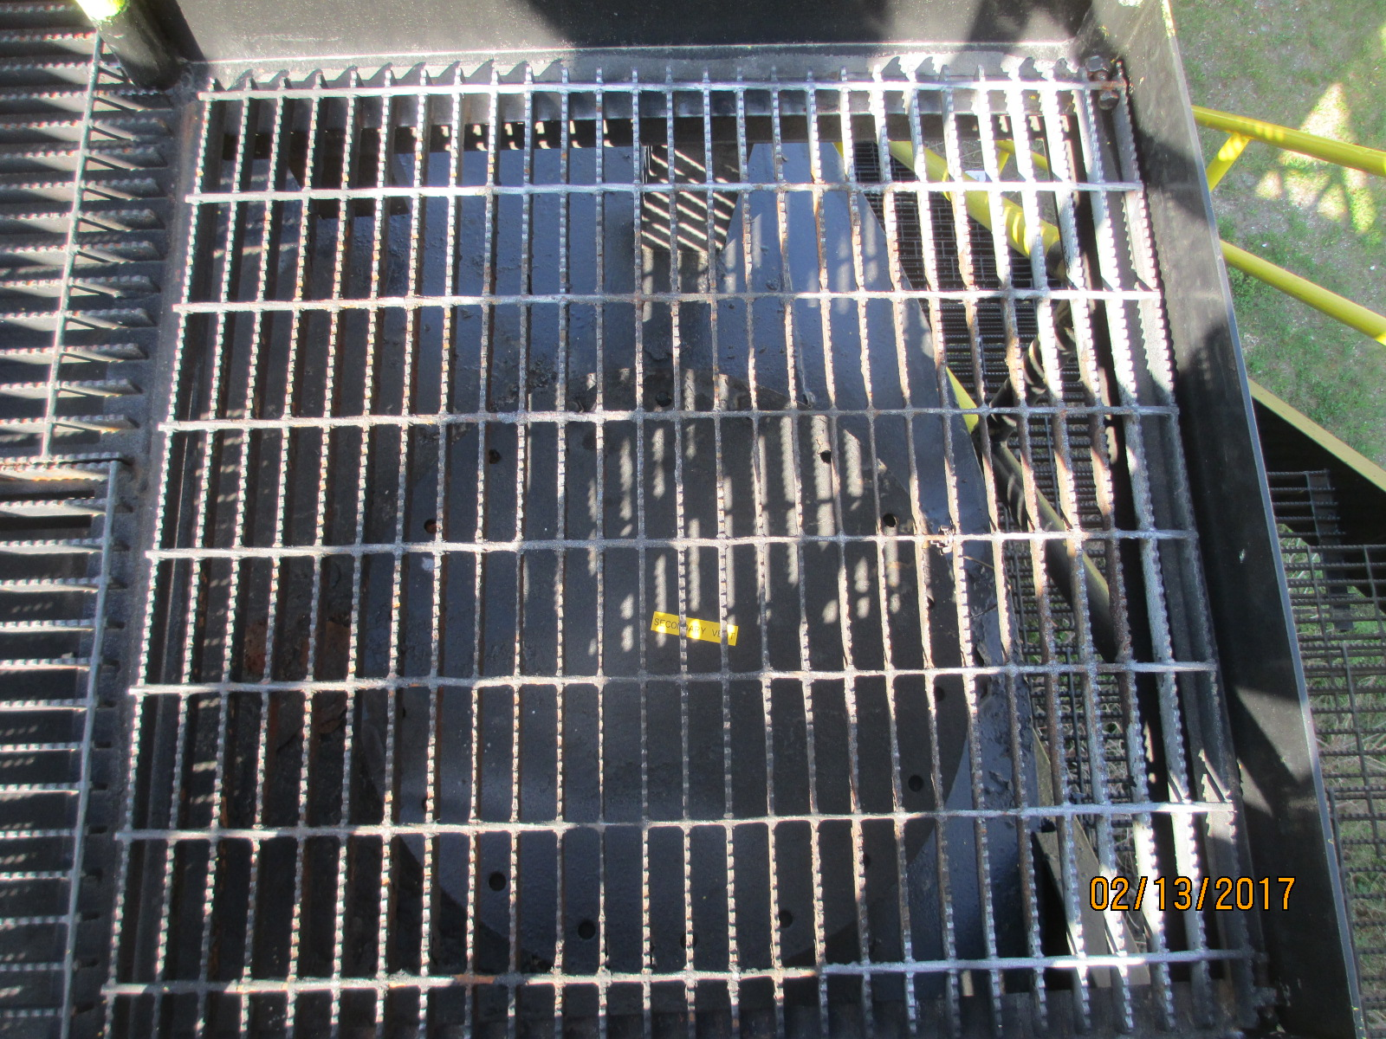

Photo 2

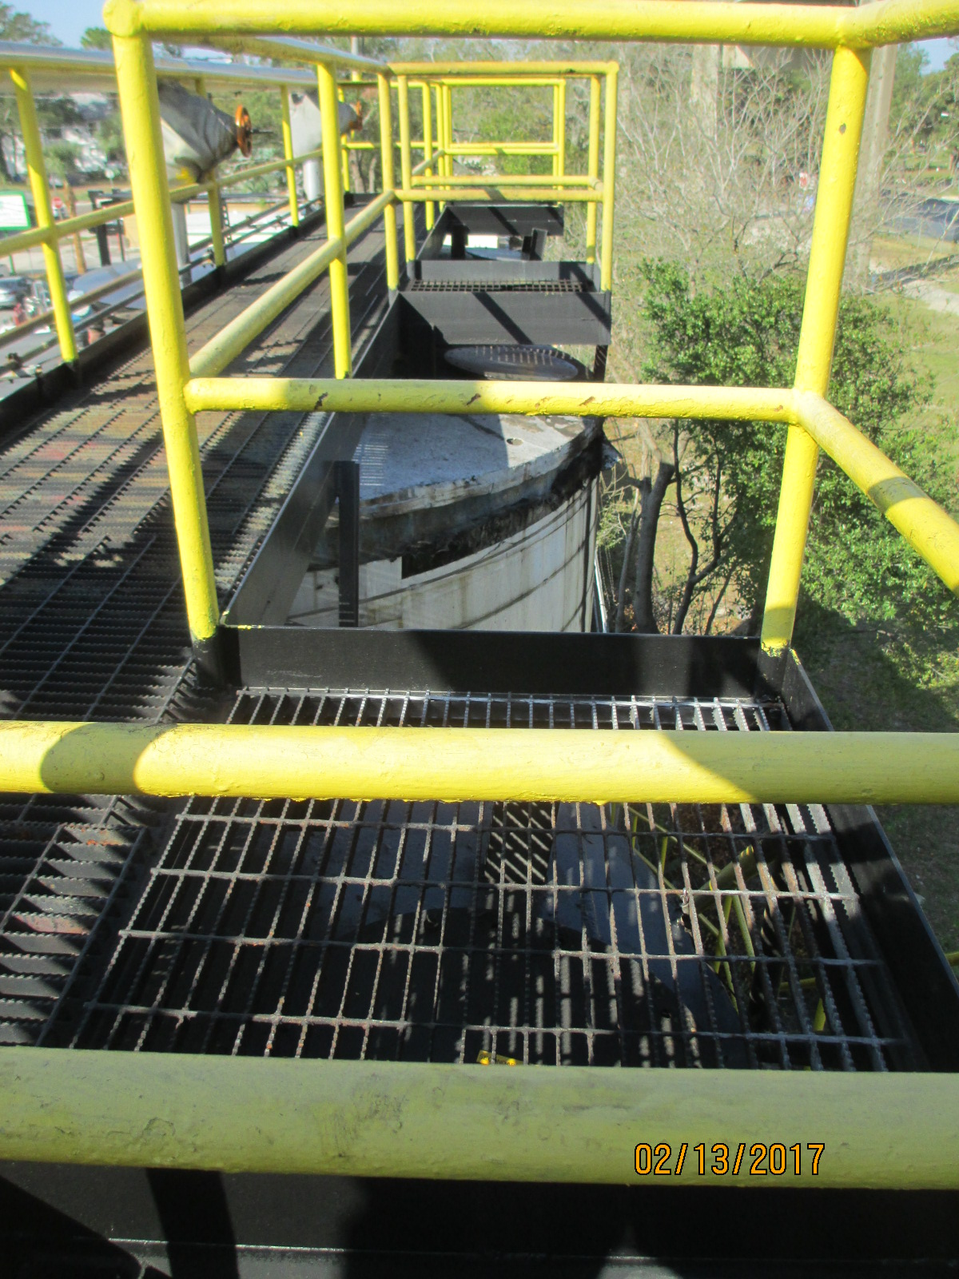

Photo 3

Attachment 1
Attachment 2

