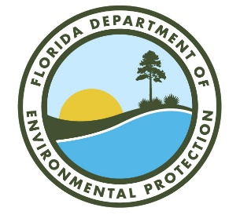

*Northeast District*

*Meeting Sign-In Sheet*

Meeting:***Water Recovery, Inc.***Date:  *March 12, 2021* Time: *1:00 p.m.*

|  |  |  |  |
| --- | --- | --- | --- |
| Name | Organization | Phone # | E-mail Address |
| Heather Webber | DEP NED Environmental Administrator | 904-256-1622 | heather.webber@floridadep.gov |
| Bonnie Bradshaw | DEP NED HW Subject Matter Expert | 904-256-1638 | bonnie.bradshaw@floridadep.gov |
| Cheryl Mitchell | DEP NED HW Subject Matter Expert | 904-256-1620 | cheryl.l.mitchell@floridadep.gov |
| Patrick Reynolds | DEP Office of General Counsel | 850-245-2285 | patrick.reynolds@floridadep.gov |
| Bryan House | Moran Environmental |  | bhouse@moranenvironmental.com |
| Nathan McLellan | Moran Environmental |  | nmclellan@moranenvironmental.com |
| Edward Maylon | Water Recovery, Inc. | 904-475-9320 | emaylon@wrijax.com |
| Amanda Kimball | Water Recovery, Inc. | 904-475-9320 | akimball@wrijax.com |
| Stacy Watson | HK Law | 904-798-7321 | Stacy.WatsonMay@hklaw.com |
|  |  |  |  |
|  |  |  |  |
|  |  |  |  |
|  |  |  |  |