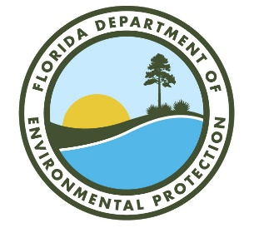

***Northeast District (NED)***

***MS Teams* Meeting Sign-In Sheet***

Meeting: *Ring Power Corp. (St. Augustine) Date: November 29, 2022* Time: *12:30 p.m.*

|  |  |  |  |
| --- | --- | --- | --- |
| Name | Organization | Phone # | E-mail Address |
| Jim Maher | DEP NED Assistant District Director | 904-256-1650 | jim.maher@floridadep.gov |
| Joni Petry | DEP NED Environmental Administrator | 904-256-1606 | joni.petry@floridadep.gov |
| Cheryl Mitchell | DEP NED Hazardous Waste Subject Matter Expert | 904-256-1620 | cheryl.l.mitchell@floridadep.gov |
| Bonnie Bradshaw | DEP NED Hazardous Waste Subject Matter Expert | 904-256-1638 | bonnie.bradshaw@floridadep.gov |
| Emma Sacchitello | DEP NED Hazardous Waste Inspector | 904-256-1668 | emma.sacchitell@floridadep.gov |
| David Harriman II | Ring Power Environmental Manager | 904-494-7445 | david.harriman@ringpower.com |
| Shane McLaughlin | Ring Power Vice President of Facilities |  | shane.mclaughlin@ringpower.com |
|  |  |  |  |
|  |  |  |  |
|  |  |  |  |
|  |  |  |  |

* This meeting was held virtually via MS Teams.