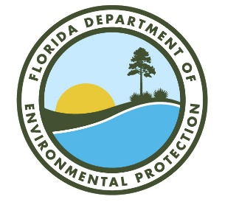

***Northeast District (NED)***

***MS Teams* Meeting Sign-In Sheet***

Meeting: *Liquid Environmental Solutions of Florida, LLC Date: July 31, 2024* Time: *1:00 p.m.*

|  |  |  |  |
| --- | --- | --- | --- |
| Name | Organization | Phone # | E-mail Address |
| Tom Kallemeyn | DEP NED Assistant District Director | 904-256-1616 | thomas.kallemeyn@floridadep.gov |
| Cheryl Mitchell | DEP NED Hazardous Waste Subject Matter Expert | 904-256-1620 | cheryl.l.mitchell@floridadep.gov |
| Bonnie Bradshaw | DEP NED Hazardous Waste Subject Matter Expert | 904-256-1638 | bonnie.bradshaw@floridadep.gov |
| Patrick Reynolds | DEP Office of General Counsel | 850-245-2285 | patrick.reynolds@floridadep.gov |
| Steve Bachellor | LES Environmental Compliance Director | 866-694-7327 | [steve.bachellor@liquidenviro.com](mailto:steve.bachellor@liquidenviro.com) |
| Joe Mayberry | LES Processing Facility Manager | 866-694-7327 | [joe.mayberry@liquidenviro.com](mailto:joe.mayberry@liquidenviro.com) |
| Ken Khim | LES Plant Supervisor | 904-265-2104 | ken.khim@liquidenviro.com |
| John B. King | LES Outside Counsel | 225-381-8014 | [john.king@bswllp.com](mailto:john.king@bswllp.com) |
|  |  |  |  |
|  |  |  |  |
|  |  |  |  |

* This meeting was held virtually via MS Teams.