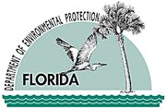

Jeb Bush
Governor
Department of
Environmental Protection
Central District
3319 Maguire Boulevard, Suite 232
Orlando, Florida 32803-3767
Printed on recycled paper.
David B. Struhs
Secretary
"More Protection, Less Process"

September 5, 2003

ELECTRONIC MAIL
Cindy.Bruce@Safety-Kleen.com

Safety-Kleen OCD-HW-C-03-0208
600 Central Park Drive
Sanford, Florida 32771

Attention: Cindy Bruce, Branch Manager

Orange County – HW
Safety-Kleen
FLD984171165
Inspection Summary

Dear Ms. Bruce:

A hazardous waste compliance inspection was conducted at your facility on August 20, 2003. The inspection was conducted under the authority of Section 403.091, Florida Statutes, and Chapter 403, Part IV, Florida Statutes, and is designed to determine the compliance status of your facility with Title 40 Code of Federal Regulations Parts 260 through 268, and 279 as adopted in Florida Administrative Code (F.A.C.) Chapters 62-710 and 62-730.

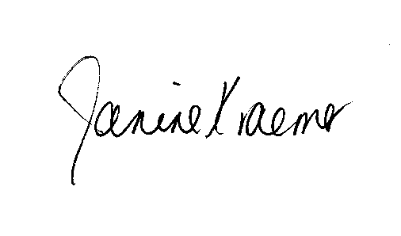
Your facility was found to be in compliance with the regulations noted above at the time of the inspection. Please review the enclosed inspection report. If you have any questions, please call me at (407) 893-3323.
Sincerely,

Janine Kraemer
Environmental Specialist
Hazardous Waste Program

Enclosures:
RCRA Inspection Report

cc: Mike Redig, FDEP, Tallahassee, mike.redig@floridadep.net
Laurie DiGaetano, EPA Region 4, digaetano.laurie@epa.gov

