Interoffice Memorandum
_____________________________________________________________________

TO: File: Friends Recycling, C&D Disposal and Recycling Facility

From: Kimberly Rush

Date: July 25, 2013

Subject: Intent to Issue – Permit Application No. 0019600-008-SO-24
____________________________________________________________________

A search of the Legal Case Tracking System for this application number on July 25, 2013, resulted in the message “Query retrieved 0 records,” indicating that no petition was filed in response to the published notice on July 10, 2013.

/kr

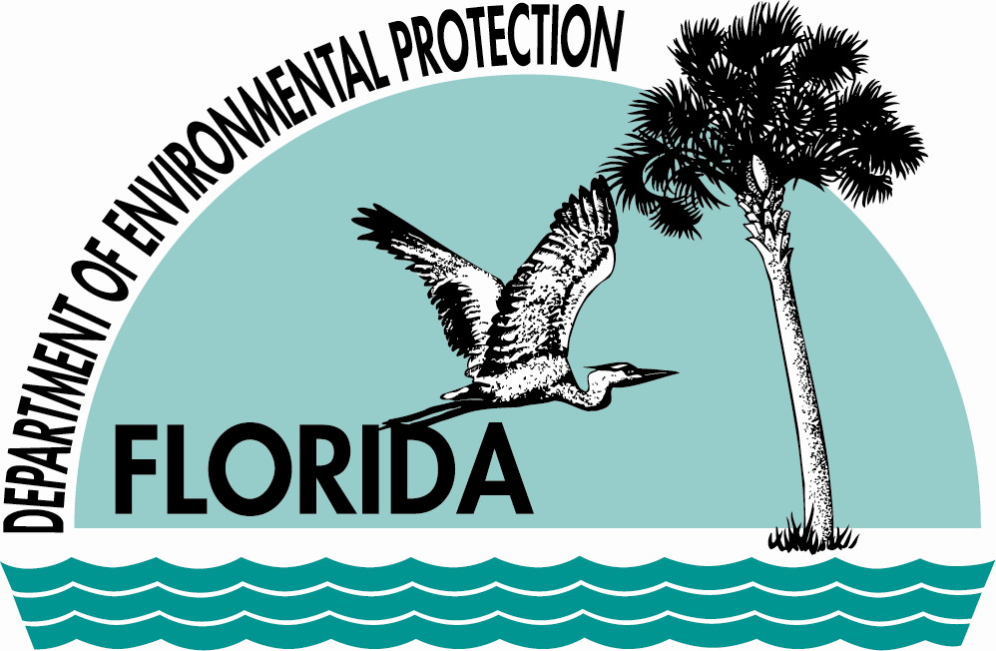 | FLORIDA DEPARTMENT OF  ENVIRONMENTAL PROTECTION  CENTRAL DISTRICT  3319 MAGUIRE BOULEVARD, SUITE 232  ORLANDO, FLORIDA 32803-3767 | RICK SCOTT  GOVERNOR  HERSCHEL T. VINYARD JR.  SECRETARY

