STATE LANDS LEASE INSPECTION
IN COMPLIANCE? | No | BOT Number: | 110028415
ERPce Project #: | 326708 | Requested by: | Celeda Wallace
ERPce Site #: | 128496 | Date Requested:
Property ID #: | 12120000606 | Date Sent to DSL:
Term: | 7 years | Date of Inspection: | May 25, 2023
Issued: | May 14, 2021 | Inspector Name: | Jacob Poirier
Expiration: | August 27, 2028 | Telephone #: | 239-344-5680

Type of Inspection:
☐ Renewal ☐ Assignment ☐ Modification ☑ Mid-Term ☐ Other:

Attachments:
☑ Photographs ☑ Surveys/Drawings ☐ Other:

SITE/CONTACT INFORMATION:
Lessee: | Mangrove Bay Homeowner’s Association, Inc. |  | AKA/FKA/ADA:
Current Owner: | Resort Management |  | Email: | Unknown
Contact Person: | Stephen Cloetingh |  | Title: | Director
Telephone #: | Unknown |  | County: | Collier
Facility Address: | 101 Goodlette Frank Road S, Naples, FL 34102
Waterbody | Gordon River |  | Class: | III
Aquatic Preserve? | No
OFW? | No
Is the lessee information correct? |  | Yes

SLIP INFORMATION:
- Number of slips authorized in lease & Number observed: | 6/56 (50 outside of state lands, see #4 below)
- Number of wetslips for public rental on state lands: | 0
- Are 90% open to the public? | ☐ Yes ☑ No ☐ N/A ☐ See Comments
- Number of wetslips on privately owned land: | 50
- Number of upland dry storage units/slips: | 0
- Does there appear to be liveaboards within the lease area? | ☐ Yes ☑ No ☐ N/A ☐ See Comments
- Is ALL mooring within the lease boundaries? | ☑ Yes ☐ No ☐ N/A ☐ See Comments
- Were past aerials reviewed for mooring compliance? | ☑ Yes ☐ No ☐ N/A ☐ See Comments

LEASE INFORMATION:
- What is the current upland use? | Residential Subdivision
a. Has the upland use changed? | ☐ Yes ☑ No ☐ N/A ☐ See Comments
- Number of upland residential units: | 53
- What is the linear footage of shoreline owned by the applicant immediately adjacent to sovereign submerged lands? | 300
- Are the docking structures in good condition? | ☑ Yes ☐ No ☐ N/A ☐ See Comments
- Were the dock dimensions field verified? | ☑ Yes ☐ No ☐ N/A ☐ See Comments
- Are there any over water roofed structures? | ☑ Yes ☐ No ☐ N/A ☐ See Comments
- Are there any non-water dependent uses: i.e., ship stores; gazebos; Sundecks; harbor master office; wet bar; etc.? | ☐ Yes ☑ No ☐ N/A ☐ See Comments
- Have there been any dock modifications or additions? | ☐ Yes ☑ No ☐ N/A ☐ See Comments
- Does the lease allow for mooring of “cruise to nowhere” vessels? | ☐ Yes ☑ No ☐ N/A ☐ See Comments
a. If yes, is “cruise to nowhere gambling”? | ☐ Yes ☐ No ☑ N/A ☐ See Comment
- Is the lease area used for special events (i.e. boat shows, fishing tournaments or celebrations)? | ☐ Yes ☑ No ☐ N/A ☐ See Comment
- What type of fueling is provided? | ☐ Gas ☐ Diesel ☑ None
a. Is it shown on the survey? | ☐ Yes ☐ No ☑ N/A ☐ See Comment
- What type of sewage pump-out is provided? | ☐ Portable ☐ Fixed ☑ None
a. If fixed pump-outs, are they shown on the survey? | ☐ Yes ☐ No ☑ N/A ☐ See Comment
- Are ALL lease standard conditions in compliance? | ☐ Yes ☑ No ☐ N/A ☑ See Comment
- Are ALL special lease conditions in compliance? | ☑ Yes ☐ No ☐ N/A ☐ See Comment
- Details provided on any non-compliance indicated above: cc: Public Lands Administration on Any actions taken? | ☐ Yes ☐ No ☑ N/A ☐ See Comment

ADDITIONAL INFORMATION:
- Is the marina designated as a clean marina or clean boatyard observed?  If yes, please send a copy of this inspection Brenda.Leonard@dep.state.fl.us | ☐ Yes ☐ No ☑ N/A ☐ See Comment
- Are the fees current (verify with SUPRS/ILMS)? | ☐ Yes ☑ No ☐ N/A ☐ See Comment
a. If not current, has an invoice been provided to Lessee? | ☑ Yes ☐ No ☐ N/A ☐ See Comment
- Are the revenue reports forms/slip certifications current? | ☐ Yes ☑ No ☐ N/A ☐ See Comment
a. If not current, was the Lessee provided the Forms? | ☑ Yes ☐ No ☐ N/A ☐ See Comment
- Is there any indication as to whether slips are being sold (i.e. For Sale signs at slips, internet sites, flyers, other advertising)? | ☐ Yes ☐ No ☑ N/A ☐ See Comment
a. If yes, forward the information to BPLA recurring revenue section. Date sent:

STAFF REMARKS:
21). Lease Standard Conditions:
- During the lease renewal inspection, Department staff observed a healthy mangrove fringe consisting of red and white mangroves along the shoreline of the lessee property. It was noted that the portions of the mangrove fringe located landward of the docking structures authorized in this lease agreement were measured to have a height of approximately 8.5 feet from the substrate (refer to Photos 6 and 7, below). Pursuant to Section 403.9326(1) of the 1996 Mangrove Trimming and Preservation Act, the trimming of mangroves so that the overall height of any mangrove is reduced to no less than 6 feet as measured from the substrate is exempt from permitting requirements provided that no more than 65 percent of the mangroves along the shoreline are trimmed if the shoreline is greater than 150 feet in length. A file review conducted by Department staff determined that fewer than 65 percent of the mangroves observed along the shoreline were trimmed. Therefore, the trimming activity conducted on the observed mangrove fringe is exempt from the need for a Mangrove Trimming Permit from the Department (Please refer to the attached “Updated Inspection Report” for more information on site compliance with mangrove trimming).
- All lease standard conditions are not in compliance. This lease agreement references Environmental Resource Permit No. 11-128496-010 and Modified Environmental Resource Permit Nos. 0128496-011 EM (File No. 0128496-011 EM) and 0128496-013 EM (File No. 0128496-013 EM). See the attached “Permit Conditions” document for more details on the permit conditions.
  - A file review of Department records found that a Compliance Assistance Offer (CAO) letter was issued to the lessee in response to a permit compliance and lease renewal inspection on 6/26/2020. As of 8/1/2023, all Recommendations for Correct Action listed in the CAO letter and inspection report were not complete. In addition, a lease renewal and follow up permit compliance inspection conducted by Department staff on 5/25/2023 discovered additional non-compliance with the above referenced Permit and File Nos. Please refer to the attached “Updated Inspection Report” for more information on site compliance.

22). Special Lease Conditions:
30(a): Any vessel moored at the docking facility, on either a temporary or permanent basis, shall be wholly located within its designated wet slip as depicted on Attachment A and no portion of a vessel may extend beyond the leased premises. Vessel length shall be measured as overall length including all parts and accessories such as outboard motors, bow pulpits, and swim platforms. IN COMPLIANCE.
30(b): Vessels that either do not possess a current vessel registration and title as required by Chapters 327 and 328, Florida Statutes, or do not have a current vessel registration and title as required in another state or country are prohibited within the leased premises. IN COMPLIANCE.
30(c): All vessels that moor, dock, or otherwise use the leased premises shall be maintained in a fully operational condition. IN COMPLIANCE.
30(d): Use of the wet slips shall be restricted to persons who have a real property interest in a dwelling unit in Mangrove Bay. IN COMPLIANCE.

25). The lessee is required to complete payment for Invoice 124752 (see “Attachment – Invoice 124752”).

26). The lessee is required to complete and submit the annual revenue reports for the following time periods:
- 2021-2022

The reporting forms for this time period have been included with this lease inspection report (see “Attachment – Annual Revenue Report”).

RECOMMENDATIONS FOR CORRECTIVE ACTION:
FOR LESSEE:
Please refer to the attached “Updated Inspection Report” for Department Recommendations for Corrective Action.
FOR LESSOR:
Lease is not in compliance, do not renew until lessee returns to compliance.

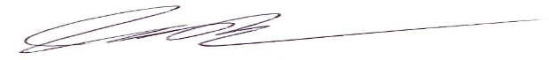 | May 25, 2023
Jacob Poirier , Environmental Specialist II | Date

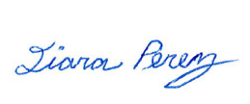 | September 6, 2023
Qiara Perez , Environmental Manager | Date

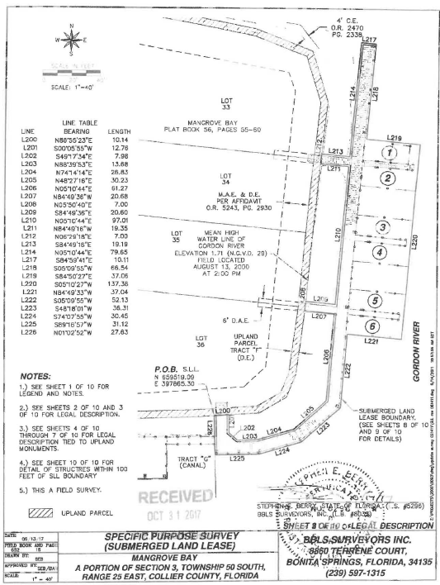

Figure 1: View of submerged land lease survey included in BOT No. 110028415.

Image #: | 1
Photo Description: | View of docking facility located on state lands, indicating the commencement of the lease area. Facing northeast.
Photo Location:  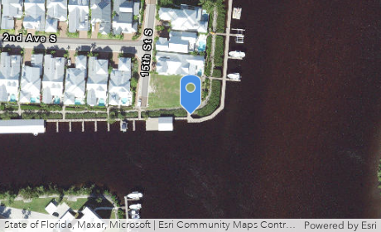 |  | 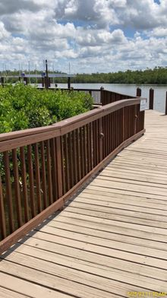
Image #: | 2
Photo Description: | View of Slips #1-6 located within lease area, facing north.
Photo Location:  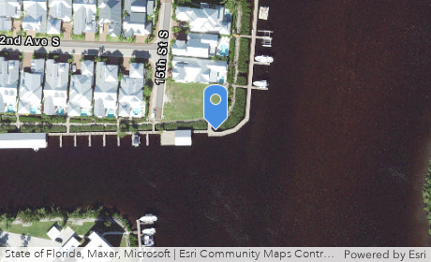 |  | 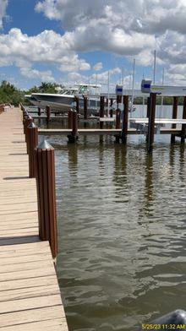
Image #: | 3
Photo Description: | View of finger pier containing Slips #1-2 located in lease area, facing east.
Photo Location:  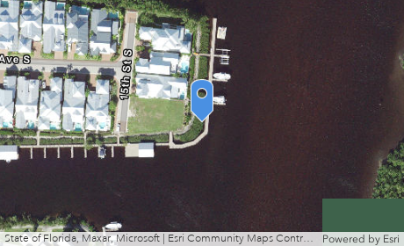 |  | 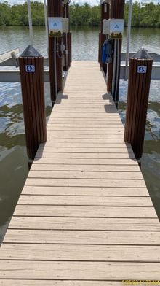
Image #: | 4
Photo Description: | View of finger pier containing Slips #3-4 in lease area, facing northeast.
Photo Location:  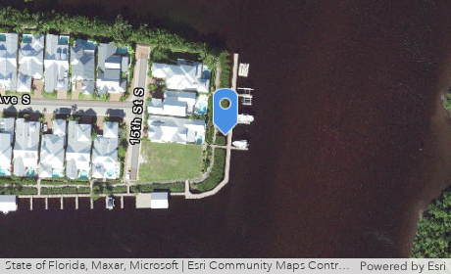 |  | 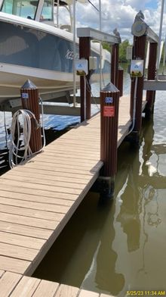
Image #: | 5
Photo Description: | View of registration tag on vessel wholly contained in slip within lease area. The registration is up to date and in compliance with Special Lease condition 30(b). Facing northeast.
Photo Location:  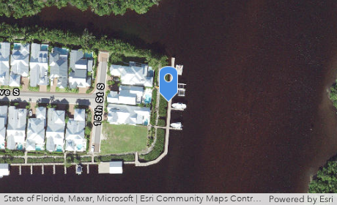 |  | 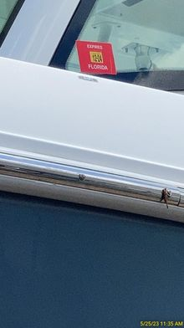
Image #: | 6
Photo Description: | View of healthy, trimmed red and white mangroves located landward of docking facility in lease, found to be approximately 8.5 feet in height as measured from the substrate. The observed trimming activity was determined to be exempt, pursuant to Section 403.9326, F.S. Facing west.
Photo Location:  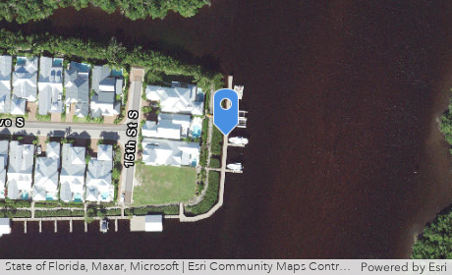 |  | 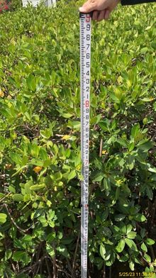
Image #: | 7
Photo Description: | View of healthy, trimmed red and white mangroves located landward of docking facility in lease. The observed trimming activity was determined to be exempt, pursuant to Section 403.9326, F.S. Facing south.
Photo Location:  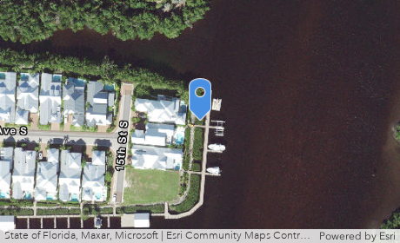 |  | 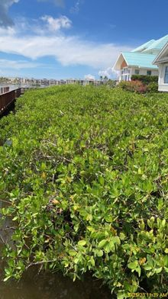
Image #: | 8
Photo Description: | View of docking structure in lease area, facing south.
Photo Location:  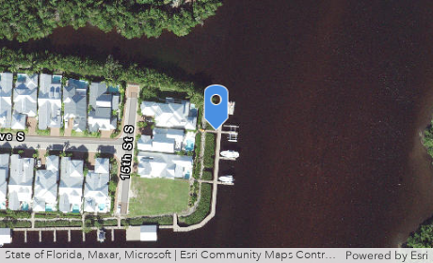 |  | 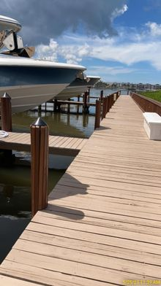
Image #: | 9
Photo Description: | View of docking structure in lease area, facing north.
Photo Location:  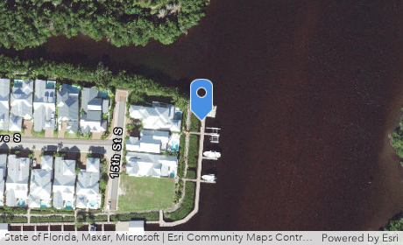 |  | 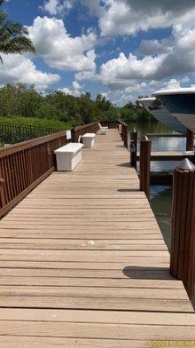
Image #: | 10
Photo Description: | View of finger pier containing Slips #5-6 in lease area, facing east.
Photo Location:  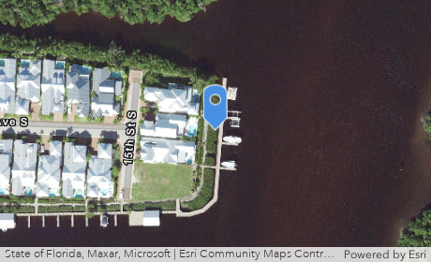 |  | 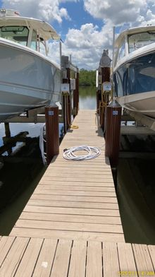
Image #: | 11
Photo Description: | View of vessel located wholly within slip in lease area and in compliance with special lease condition 30(a). Facing northeast.
Photo Location:  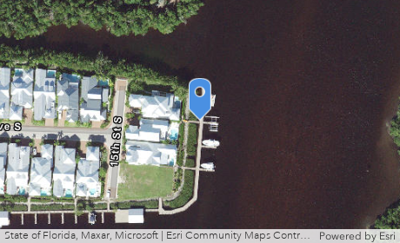 |  | 